**ABOUT US**

* PD Ryan Services (‘’PD Ryan’’) is a corporate service outfit that enhances the actualization of business goals and objectives through the provision of tailored advisory services to organizations.
* Our vision is to be lead corporate governance advisors, corporate secretaries and trainers; providing bespoke advice, solutions, and services to profitmaking and not-for-profit organizations globally.
* Our mission is commitment to excellent service delivery to ensure client satisfaction while building relationships and trust with our clients and raising a happy team that learns continually.
* At PD Ryan, we are passionate and focused on providing practical and timely solutions to our clients.

**SERVICES**

**Corporate Governance**

* Design and review of Corporate Governance Framework
* Advise, review and drafting of Board and Committee Charters
* Advise, review and drafting of Corporate Policies
* Corporate governance review to ascertain an organisation’s level of compliance with corporate governance principles
* Board evaluation to ascertain the effectiveness of the committees, board and individual directors of an organisation

**Regulatory Compliance**

* Compliance review, due diligence checks and advise
* Assistance with the procurement of the requisite permits for business operations Nigeria (business permit, expatriate quotas, CERPAC, NIPC and NOTAP registration and others)
* Filing of the requisite returns at the Corporate Affairs Commission, the Financial Reporting Council, the Securities and Exchange Commission, Nigerian Exchange Group and other regulators;

**Business Registration**

* Advise and assist with the incorporation or registration of profitmaking and not-for-profit organisations at the Corporate Affairs Commission
* Headhunting and nomination of directors for appointment to fulfil regulatory requirement (for foreign owned companies).
* Assistance with bank account opening
* Availability of shelf companies

**Trademarks**

* We advise and assist with trademark registration and renewal in Nigeria

**Taxation**

* Tax advisory services
* Tax filings

**Company Secretarial Services**

* Preparation and circulation of notices and agenda, action points and resolutions of Board and Committee Meetings, Annual General and Extraordinary General Meetings;
* Attending and taking record of minutes at Board, Committee and Annual General Meetings as well as Extra Ordinary General Meetings;
* Compiling, maintaining and updating of statutory records and registers;
* Advising on the constitution of meetings during and outside meetings;
* Recording and issuing share certificates as appropriate; and
* Liaising with auditors, bankers, regulators and other third parties (as authorized) to ensure a smooth run of the client’s business.

**Training**

* Induction of Directors and Senior Executives of newly incorporated/registered organisations as well as newly appointed Directors or Senior Executives
* Coordination and Facilitation of Board and Management Retreats
* Leadership and Management Trainings
* Coordination and Facilitation of Team Bonding Events

**Insolvency Services**

* Advise and assist with the winding up and dissolution of companies
* Advise and assist with striking off the name of a company form the register of companies at the Corporate Affairs Commission

**OUR TEAM**

**Clementina Ramsey-Osere** is the Founder/CEO of PD Ryan Services. She is a Corporate Lawyer, a Chartered Secretary and holds a Master’s in Business Administration (MBA) in Finance and Investment. Clementina is a member of the Nigerian Bar Association (NBA) and an Associate Member (ACIS) of the Institute of Chartered Secretaries and Administrators of Nigeria (ICSAN) and is a certified corporate governance auditor and board evaluator.

Clementina has acted as company secretary of different companies mainly in the fintech, financial services, health, agriculture, manufacturing, aviation, energy, oil and gas, real estates and hospitality sectors and has advised on various subjects bothering on corporate law, corporate governance, company formation, stakeholders’ engagement, regulatory compliance, trust, immigration, insolvency and taxation.

She is skilful in boardroom management as well as organising of corporate events such as board retreats, induction and trainings.

Clementina has reviewed and drafted several service, procurement and employment contracts, she has designed corporate governance frameworks, drafted and reviewed internal policies for a number of companies across sectors.

**Co-Founder**

**Ramsey Prince Osere** is a Co-Founder of PD Ryan Services. He is a self-driven professional, with result-oriented leadership skills aimed at improving productivity and profitability by fostering a result-driven, competent, and engaged workforce of any organization. He is an experienced Business Leader, Management Development Consultant, Training and Organizational Development Consultant. Ramsey is a season Business Administrator with core experience in Operations Management, Human Resources Management, IT Management as well as Marketing and Business Development.

He holds a B.Sc. Degree in Public Administration, A Master’s Degree in Business Administration (MBA) Finance and Investment, and a Master’s Degree in Legal Studies. He is a Fellow of the Institute of Management Consultants (IMC-Nigeria) and an accredited Management Trainer of the Nigerian Council for Management Development.

**Partner**

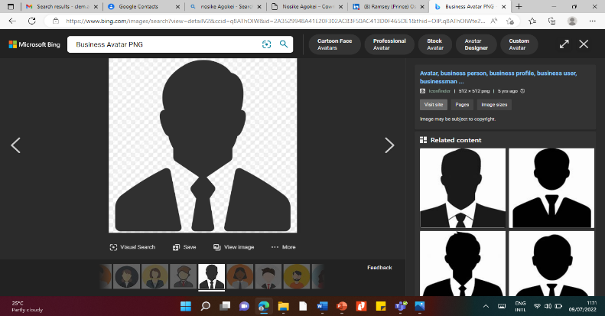**Chryss Ayakor, MBA, ACIPM, ACIS, ACA [DETAILS WILL BE PROVIDED SOON]**

**Consultant**

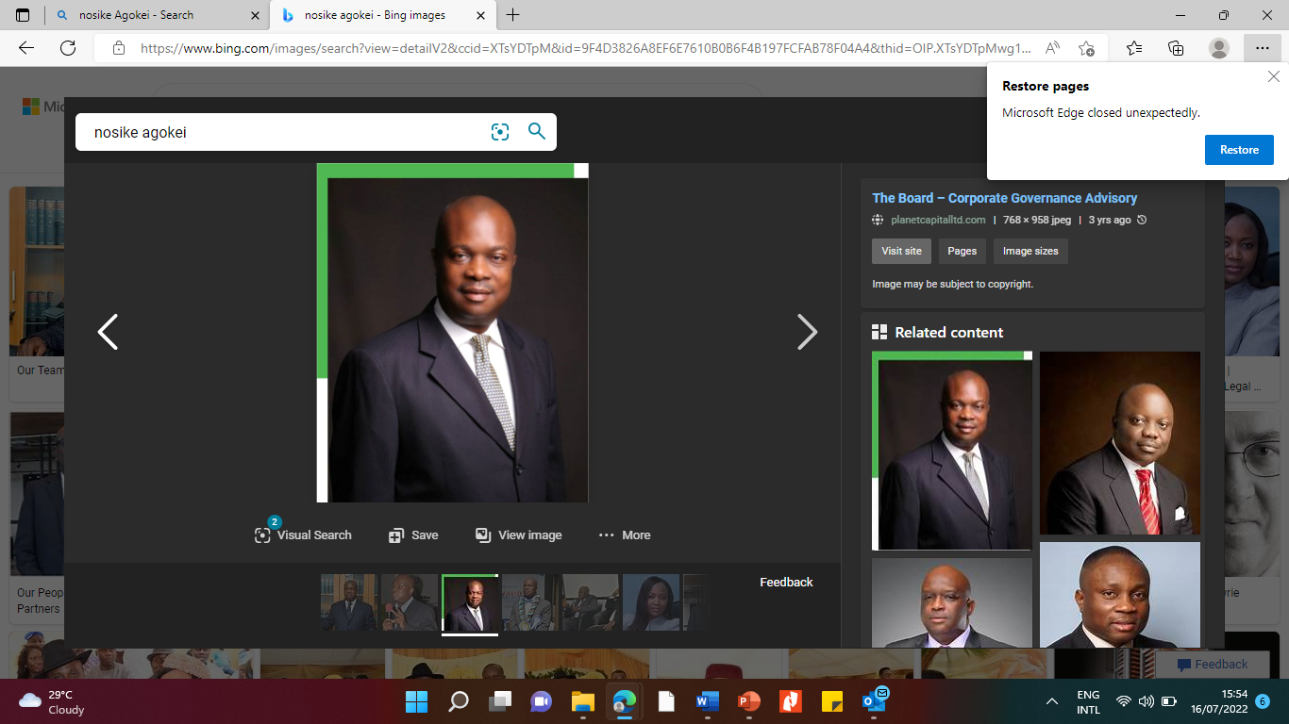**Dr Nosike Agokei** is a seasoned Corporate Manager, Boardroom Expert, Legal Practitioner, Banker, Economist, Corporate Governance expert, Chartered Secretary, Arbitrator, a Chartered Accountant, a certified Anti-Corruption Compliance Practitioner, and an International Finance Corporation (IFC) certified Board and Governance Evaluator.

He holds degrees of BSC Econ (University of Ibadan, Nigeria), MSC Econ (Enugu State University of Science & Technology, Nigeria), Doctorate Degree (DBA), University of Liverpool, England, United Kingdom, LLB (University of Lagos, Nigeria), and BL (Nigeria Law School).

Also, he holds professional qualifications of FCA (Fellow Institute of Chartered Accountants of Nigeria), FCIS (Fellow, the Chartered Governance Institute, United Kingdom), FCIArb (Fellow, Chartered Institute of Arbitrators, United Kingdom), FCIB (Fellow, Chartered Institute of Bankers of Nigeria), and ACTI (Associate, Chartered Institute of Taxation of Nigeria.

Dr Agokei served in several senior management positions in several companies, including AG Leventis Nigeria PLC, Nigerian Breweries PLC, and First City Monument Bank PLC (which was then First City Merchant Bank Group) and John Holt Plc where he served in several positions, including the position of MD/CEO. He was also Group Managing Director/CEO, MTI PLC.

**CONTACT US**

Address 42/56, Adekunle Kuye Street, Surulere, Lagos.

Telephone +2348141326334

+2348179045400 (WhatsApp Active)

Email [pdryan@pdryan.com](mailto:pdryan@pdryan.com) [this is a sample email]